Module 5: Critical Thinking Assignment

**Figure 1**

*Pseudocode for Rainfall Calculator and CSUG Bookstore*

START

FUNC get_rainfall_data()

CREATE empty list rainfall

PROMPT user for num_years

For each year:

For each month:

PROMPT user for input of rainfall for that month

APPEND inches rain to rainfall list

Return rainfall

FUNC display_rainfall_results()

COMPUTE number of months from length of rainfall

COMPUTE sum of rainfall values to get total_inches

PRINT num_months and total_inches

COMPUTE and PRINT average rainfall per month

HANDLE division by zero

FUNC bookstore()

PROMPT for user input num_books

ELSE IF 1 or fewer books

PRINT “0 points”

ELSE IF 2-3 books

PRINT “5 points”

ELSE IF 4-5 books

PRINT “15 points”

ELSE IF 6-7 books

PRINT “30 points”

ELSE IF 8+ books

PRINT “60 points”

PRINT num_points

FUNC main()

CALL get_rainfall_data()

PASS rainfall data to display_rainfall_results()

CALL bookstore()

IF __name__== ’__main__’

CALL main()

END

*Note. This pseudocode illustrates a Python program for calculating rainfall over a user-desired number of years and deciding the number of points earned from book purchases.*

**Figure 2**

*Source Code for Rainfall Calculator and CSUG Bookstore*

***# File Name: Cline_Jason_Rainfall.py***

***# Author: Jason Todd Cline***

***# Institution: Colorado State University Global***

***# Class: CSC500-1***

***# Term: 24FB***

***# Module: 5***

***# Date Created: 09/16/2024***

***# Last Modified: 09/16/2024***

**def get_rainfall_data() -> list:**

**"""**

**Prompts the user to enter the number of years and the inches of rainfall for each month of each year.**

**Returns:**

**list containing the inches of rainfall for each month.**

**"""**

**rainfall = []**

**num_years = int(input("Enter the number of years: "))**

**months_per_year = 12**

**months = {**

**1: "January",**

**2: "February",**

**3: "March",**

**4: "April",**

**5: "May",**

**6: "June",**

**7: "July",**

**8: "August",**

**9: "September",**

**10: "October",**

**11: "November",**

**12: "December",**

**}**

**for year in range(1, num_years + 1):**

**for month in range(1, months_per_year + 1):**

**inches_rainfall = int(**

**input(**

**f"Enter the inches of rainfall for {months[month]} of year {year}: "**

**)**

**)**

**rainfall.append(inches_rainfall)**

**return rainfall**

**def display_rainfall_results(rainfall: list[int]) -> None:**

**"""**

**Display the rainfall results.**

**Args:**

**rainfall (list[int]): A list of rainfall measurements.**

**Returns:**

**None**

**Prints the number of months, total inches of rainfall, and average rainfall per month for the entire period.**

**"""**

**num_months = len(rainfall)**

**total_inches = sum(rainfall)**

**print(f"Number of months: {num_months}")**

**print(f"Total inches of rainfall: {total_inches} inches")**

**try:**

**print(**

**f"Average rainfall per month for the entire period: {total_inches / num_months:.2f} inches"**

**)**

**except ZeroDivisionError:**

**print("You have entered zero. Skipping to part 2...")**

**pass**

**def bookstore() -> None:**

**"""**

**Calculates the number of points earned based on the number of books purchased.**

**Returns:**

**None**

**"""**

***# Part 2: CSU Global Bookstore***

**num_books = int(input("How many books have you purchased this month?: "))**

**if num_books <= 1:**

**print(f"You have earned 0 points for purchasing less than 2 books.")**

**elif num_books > 1 and num_books <= 3:**

**print(f"You have earned 5 points for purchasing at least 2 books.")**

**elif num_books > 3 and num_books <= 5:**

**print(f"You have earned 15 points for purchasing at least 4 books.")**

**elif num_books > 5 and num_books <= 7:**

**print(f"You have earned 30 points for purchasing at least 6 books.")**

**else:**

**print(f"You have earned 60 points for purchasing 8 or more books.")**

**def main() -> None:**

**"""**

**Main function that calculates average rainfall and bookstore points.**

**This function prompts the user to enter the number of years and the inches of rainfall for each month**

**in those years. It then calculates the total number of months, total inches of rainfall, and the average**

**rainfall per month for the entire period. If the user enters zero for the number of years, it skips to**

**the second part of the function.**

**In the second part, the function prompts the user to enter the number of books purchased in a month.**

**Based on the number of books purchased, it determines the number of points earned by the user.**

**Returns:**

**None**

**"""**

***# Part 1: Average Rainfall Over User Desired Years***

**rainfall = get_rainfall_data()**

**display_rainfall_results(rainfall)**

***# Part 2: CSU Global Bookstore***

**bookstore()**

**if __name__ == "__main__":**

**main()**

*Note. This figure displays the source code used for a Python script that has two components: calculates the average rainfall over a user-desired period and determines points earned based on the number of books purchased. The user is prompted for rainfall data across some number of years, computes the total and average rainfall, and handles errors like zero input. It also calculates the bookstore points based on the number of books purchased and displays the appropriate message based on the input.*

**Figure 3**

*Execution and Testing for Rainfall Calculator and CSUG Bookstore*

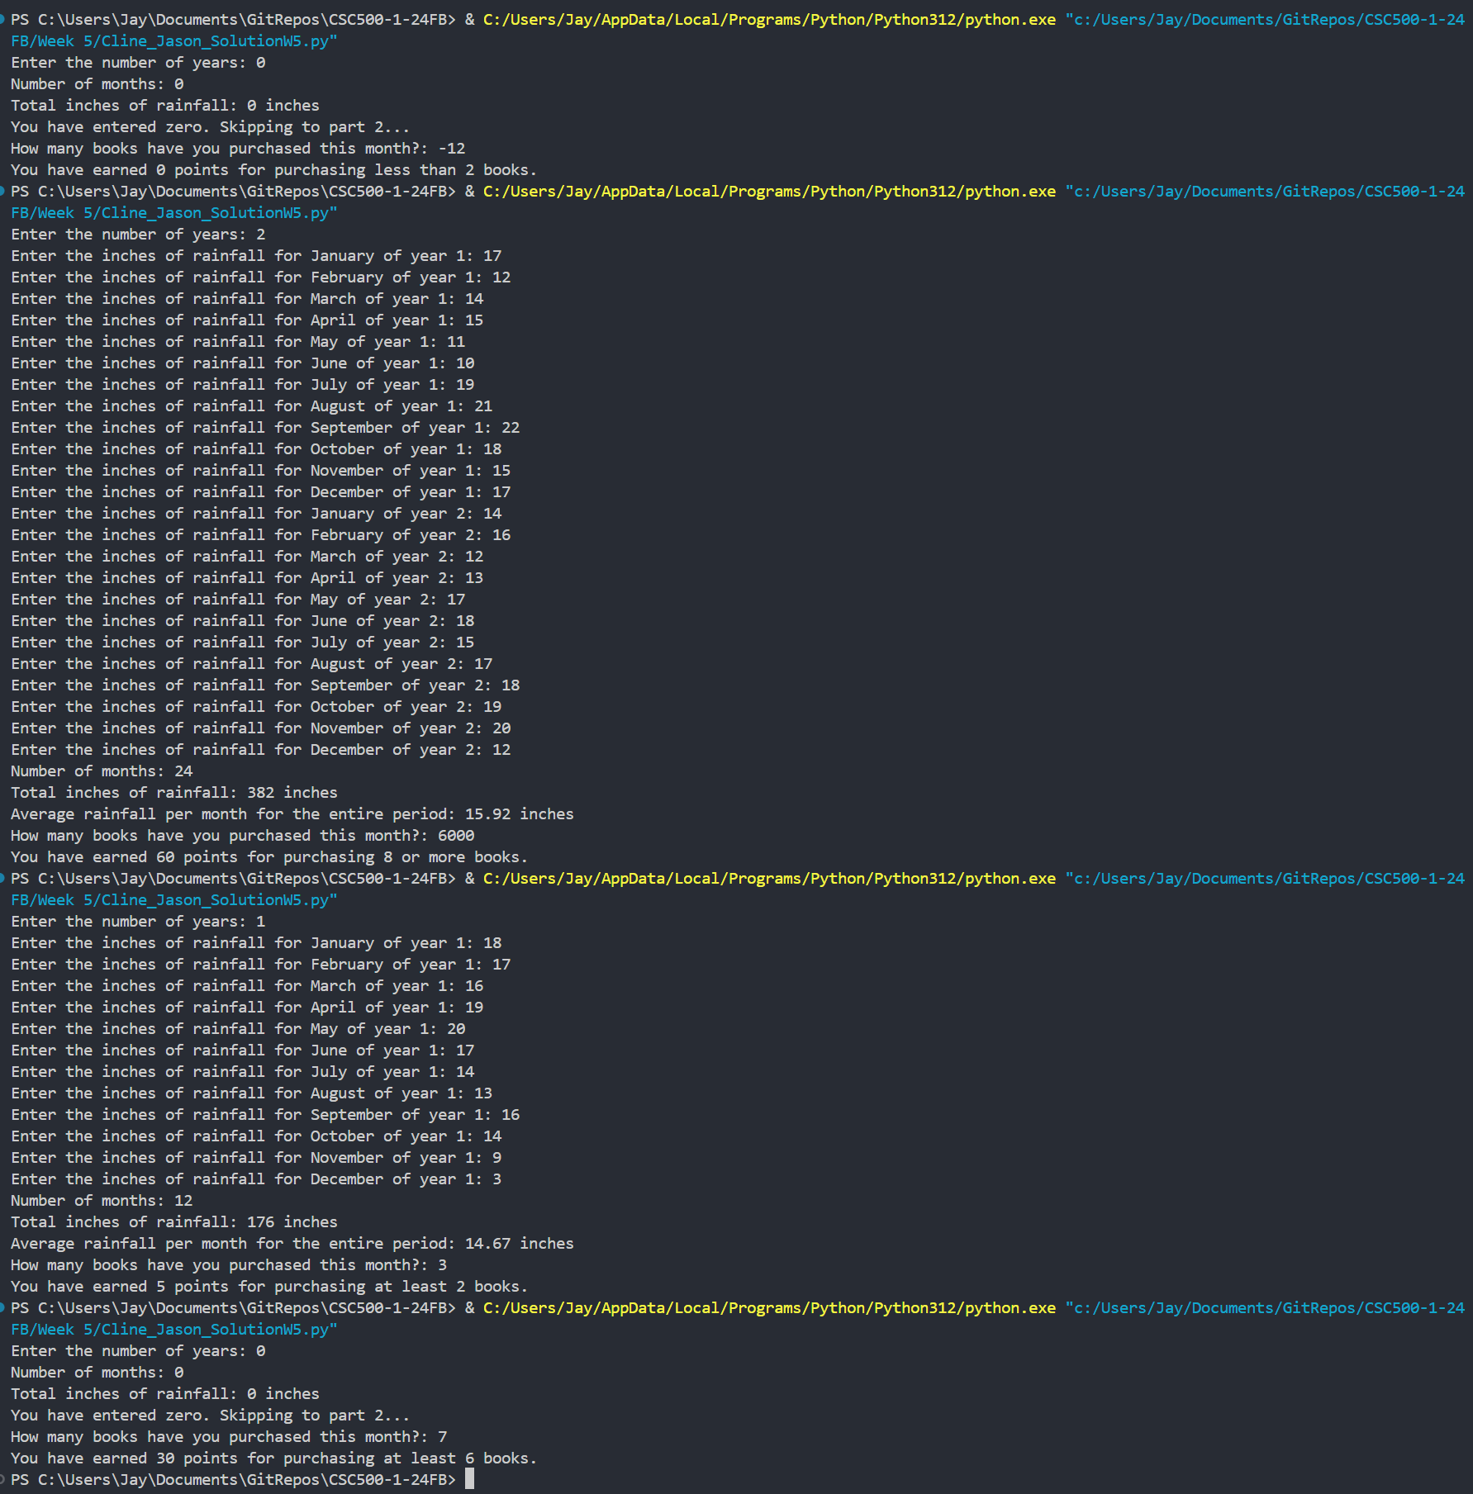

*Note. Output of a python program that calculated rainfall statistics and awarded points for book purchases. The program collects input for rainfall data and book purchases, then computes totals, averages, and assigns points based on predefined thresholds.*

References

Cline, J. T. [Jay4rmTheBay]. (2024). *CSC500-1-24FB* [Source code]. GitHub.<https://github.com/Jay4rmTheBay/CSC500-1-24FB>